Architecture is mainly a trade off analysis

Microservices architecture is iterative first disintegrating and integrating

Why need Micro services

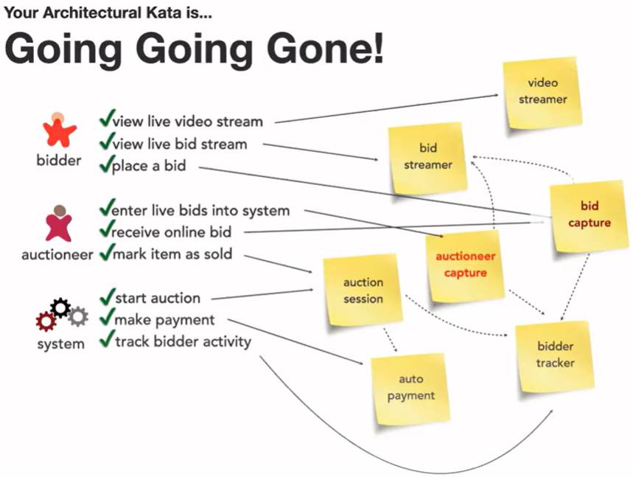

From Domain standpoint bid capture and auctioneer capture these are same but from architetcure standpoint they are very different. Auctioneer is one but bidders are thousands. So scalability , reliability is different.

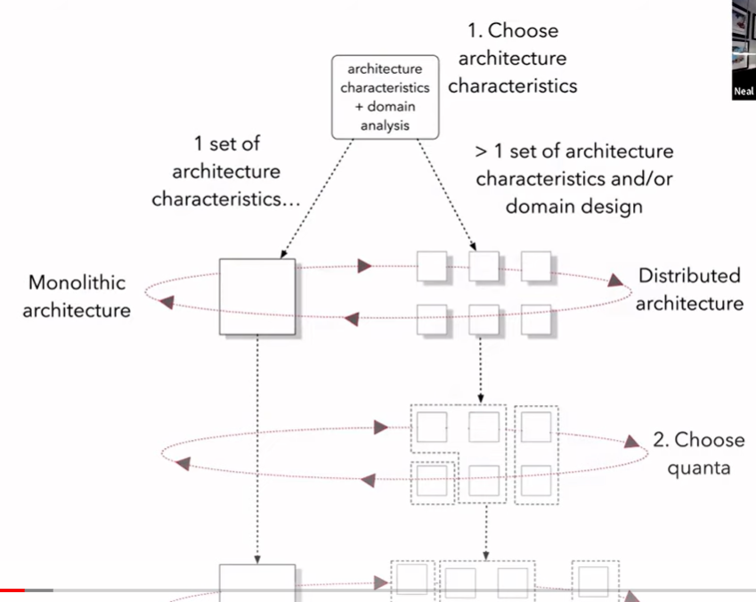

Following uis a toolbox

Characteristics of microservices  


**parses**

**Service Granularity**

Two fdifferebce firces to decide granuality

1. Granularity disintegrators
2. Granuality integrators

**Granularity disintegrators**

* F- Service functionality – single responsibility. Too much chit and slow system
* CV-Code Voltility - if some thing changes more often then others than it can be taken out
* S-Scalability through put
* S-Security
* E-Fault tolerance reliability
* Plus your organization : disintegrators

**FSC(V) SSE**

**Granularity integrators**

* **T-Transactionality: to avoid distributed transactions across micro services**
* **D-Data dependency: referential integrity less relication**
* **W-Workflow and chroregraphy:**

**Transactionality**

**Data Dependency**

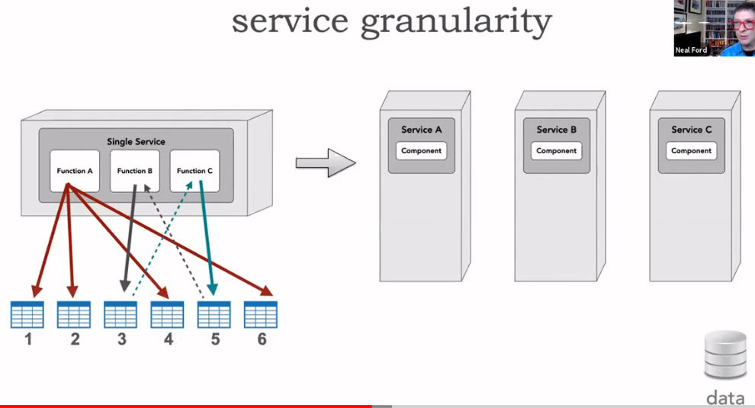

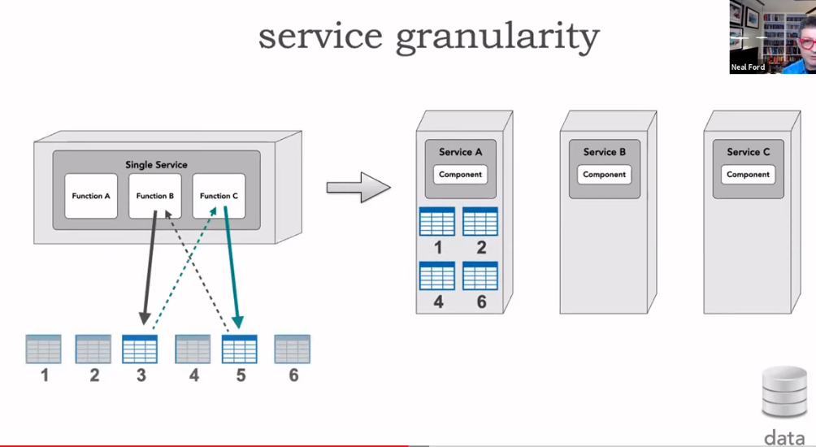

**Following idea breaks encapsulation of service C and any change in DB5 will break ServcieB**

Following is fine archirtecturteally but may introduce performance issues.

**If a lot of chat between B and C then bundle them unless they have some other architectural differences i.e. parses Perf, availability, reliability, scalability, exception/fault tolerance, security**

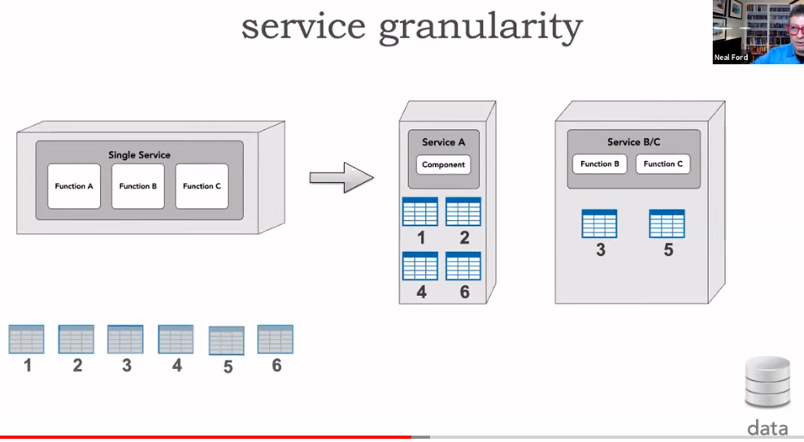

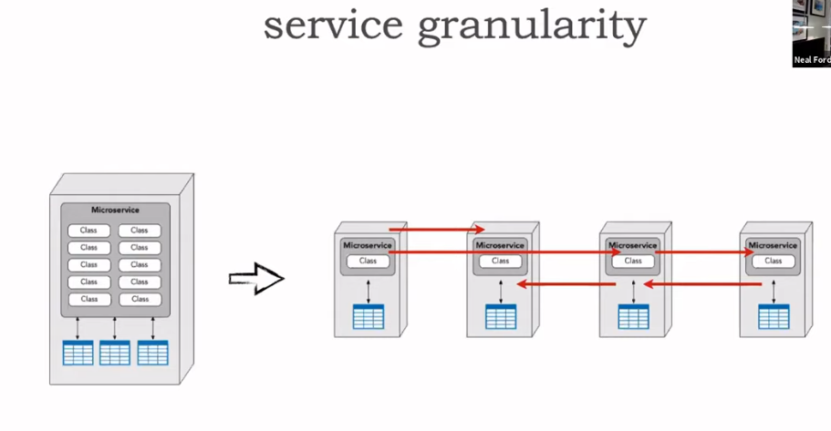

**Communication**

**Choreography**

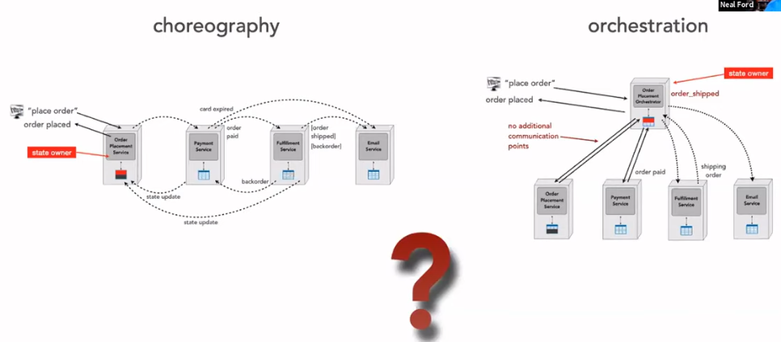

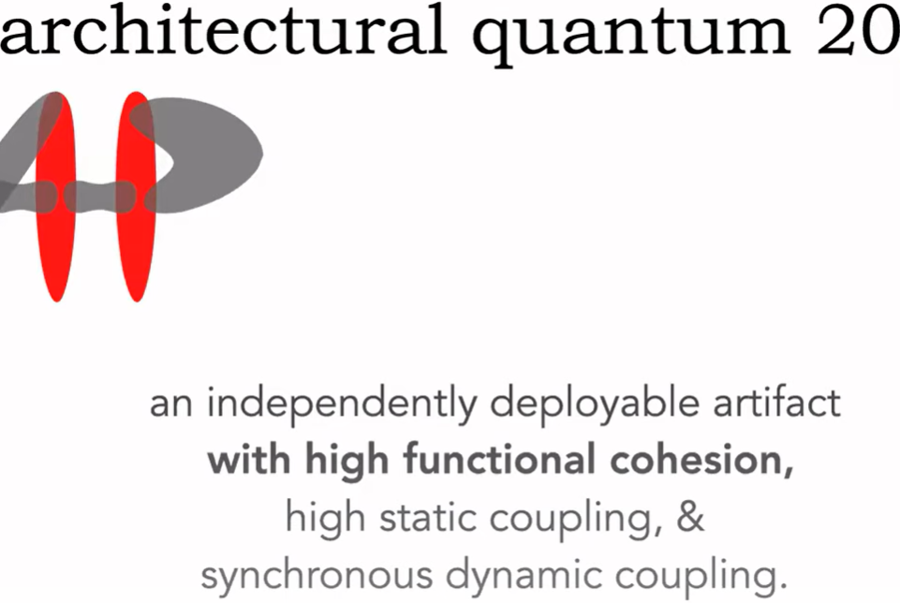

**Static dependency means all those including transitive which are required to bootstrap a service.**

